Experiment 12: Perform Perspective Transformation on an Image
Aim
To perform Perspective Transformation on an image using Python and OpenCV.
Software Requirements
- Python 3.x
- OpenCV (cv2)
- NumPy
- Visual Studio Code / PyCharm / Jupyter Notebook
Procedure
- Install the required libraries using:
- Import the required libraries (cv2 and numpy).
- Read the input image using cv2.imread().
- Check whether the image is loaded successfully.
- Select four points from the original image.
- Select four corresponding points in the output image.
- Compute the perspective transformation matrix using cv2.getPerspectiveTransform().
- Apply the transformation using cv2.warpPerspective().
- Display both the original and transformed images.
- Press any key to close all image windows.
Python Code
import cv2
import numpy as np
# Read the input image
image = cv2.imread("sample.jpg")
# Check if image is loaded
if image is None:
print("Error: Image not found!")
exit()

# Get image dimensions
rows, cols = image.shape[:2]
# Define four points in the original image
pts1 = np.float32([[50, 50],
[300, 50],
[50, 300],
[300, 300]])
# Define corresponding points in the transformed image
pts2 = np.float32([[10, 100],
[280, 50],
[80, 280],
[300, 300]]
# Compute perspective transformation matrix
M = cv2.getPerspectiveTransform(pts1, pts2)
# Apply perspective transformation
perspective = cv2.warpPerspective(image, M, (cols, rows))
# Display images
cv2.imshow("Original Image", image)
cv2.imshow("Perspective Transformed Image", perspective)
# Wait for a key press
cv2.waitKey(0)
# Close all windows
cv2.destroyAllWindows()
Output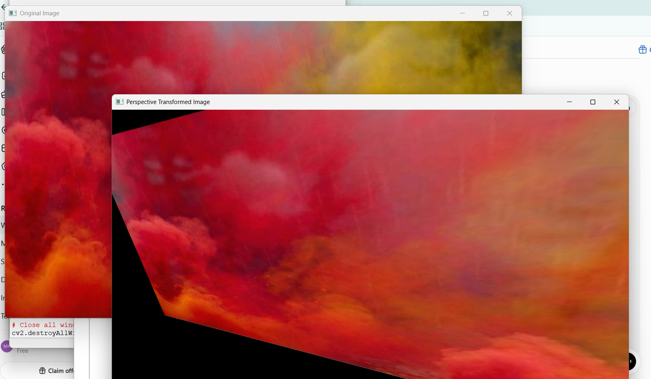
Result
The perspective transformation was successfully performed on the input image using Python and OpenCV. The transformed image was obtained by applying the perspective transformation matrix and displayed successfully.

